HAEMATOLOGY PATIENT SURVEY  In September 2023 I ran a patient experience survey that focused on the information needs of our patients in the haematology oncology ward. I wanted to find out if they were receiving the information they needed and at the right time for them, before they started treatment. Survey questionnaires were sent out to 30 patients.  The survey was also used to find out if having a pre-treatment meeting with the Haematology Clinical Nurse Specialist (CNS) would be of benefit to Haematology patients. | 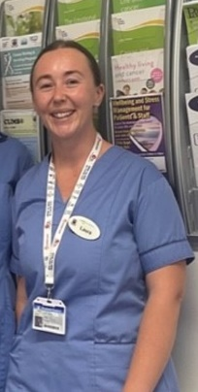  Clinical Nurse Specialist Haematology  Laura Kiernan
Results:

- 100% of patients that had met the CNS pre treatment reported feeling more prepared for treatment and 88% felt well prepared to manage treatment side effects.
- 79% would like an appointment to meet with the CNS before starting treatment. 94% said they would like a follow up call at 1 week or 1 month from the CNS.
- 71% of patients said they were aware of the support services available to them.

Patient Comments
Patients that had met the CNS before treatment reported having a very positive experience. They also commented, “Treatment commencement day is very overwhelming and a lot can go over your head.” “More information needed about where it leads to”, “why scans are needed”, “new treatments”, “how different medications work with medications you are already using”, “more family involvement needed”, information for “women who ar taking hormones”. “ Information makes you feel more relaxed”.
Action Plan
- Set up a dedicated nurse led clinic to meet patients pre treatment.
- Schedule follow up calls with patients as their preference at 1 week or one month.
- Develop end of treatment summaries.

